COMP3851A – Computing and Information Sciences WIL
INDIVIDUAL CONTRIBUTION REPORT
Name：Zheng Chenjun

GROUP PROJECTS
INDIVIDUAL SECTION
1. Detailed Individual Contribution and Responsibility Matrix
In the Job Recruitment System (JRS) project, I acted as the Lead UI/UX Designer and Front-End Developer. My technical responsibilities focused on Aim A: Self-Registration & Account Management. I translated system goals into functional requirements, constructed high-fidelity prototypes, mapped entity relationships, and wrote modular front-end code.
Core Individual Responsibilities
- Requirements Specification: I defined and mapped FR-01 (Dual-role authentication for Applicants and HR) and FR-02 (Modular candidate data store for personal summary, career history, education, skills, and certifications) directly to Aim A.
- Figma UI Prototyping: I designed the high-fidelity UI system for the Applicant Portal in Figma, creating responsive frames for desktop and mobile viewports, component variants, and interactive forms.
- Front-End Engineering: I translated the Figma prototypes into functional HTML5 and CSS3 web layouts using Flexbox, building the two-column profile interface and interactive form triggers.
- Database Alignment: I mapped the UI inputs from the applicant registration forms directly into the 3NF relational database schema, ensuring proper attribute definition for the APPLICANT_ACCOUNT and APPLICANT_PROFILE tables.
Project Deliverables Completion & Contribution Details
Deliverable / Result Section | Individual Contribution (%) | Primary Personal Contribution
Aim A Figma UI & Global Design System | 80% | Designed full high-fidelity UI screens, auto-layout frames, and interactive component libraries.
Front-End HTML/CSS Implementation | 40% | Implemented responsive Flexbox layouts, profile cards, and CSS styles based on Figma specs.
FRS Specification | 30% | Authored FR-01 and FR-02, mapped Aim A workflow requirements, and defined RBAC boundaries.
3NF Database Schema Alignment | 20% | Aligned applicant profile input fields with 3NF database entity attributes and constraints.
Project Governance & Documentation | 25% | Contributed to report sections, prepared presentation slides, and tracked personal WBS milestones.
2. Technical Artifacts and Visual Evidence
To substantiate my individual technical contributions, four key deliverables were produced during Phase 1:
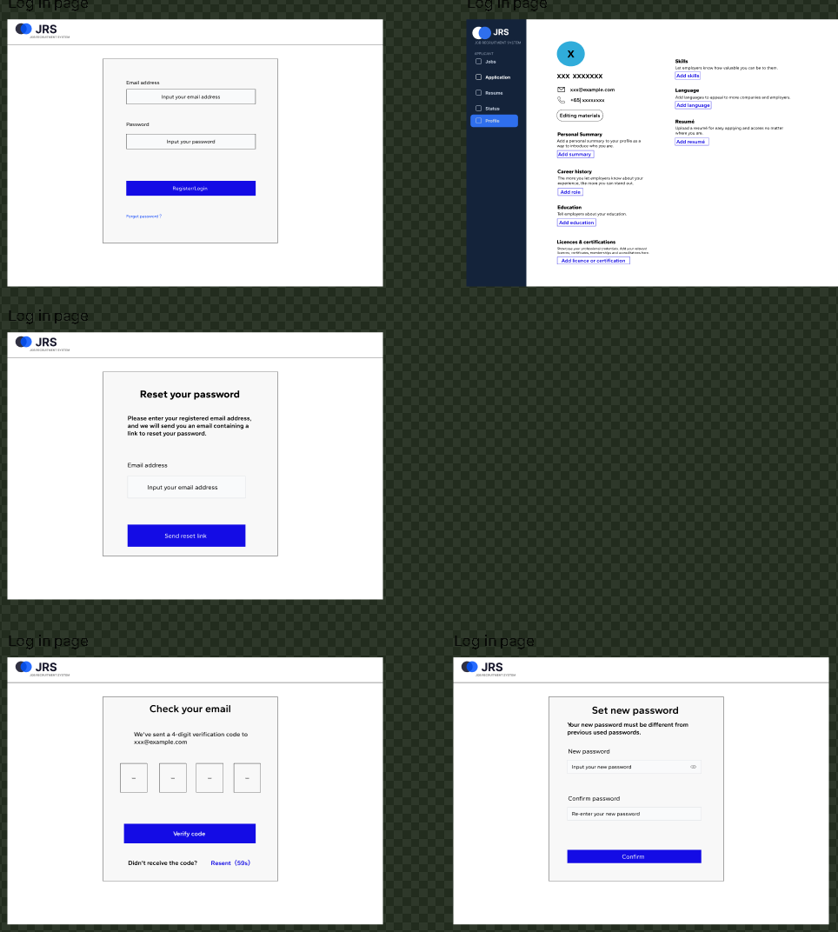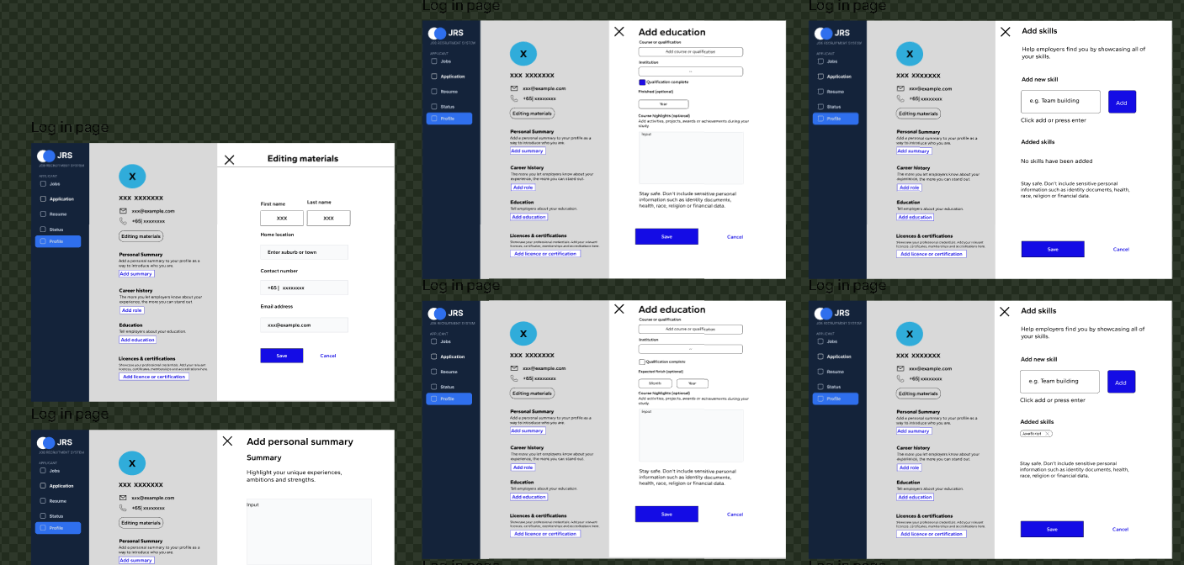
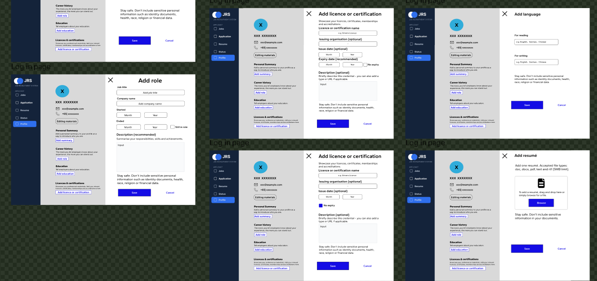
Figure 1: High-fidelity Figma design for Aim A. Interactive wireframes and component layouts designed for the applicant portal, establishing the visual layout for desktop browsers.
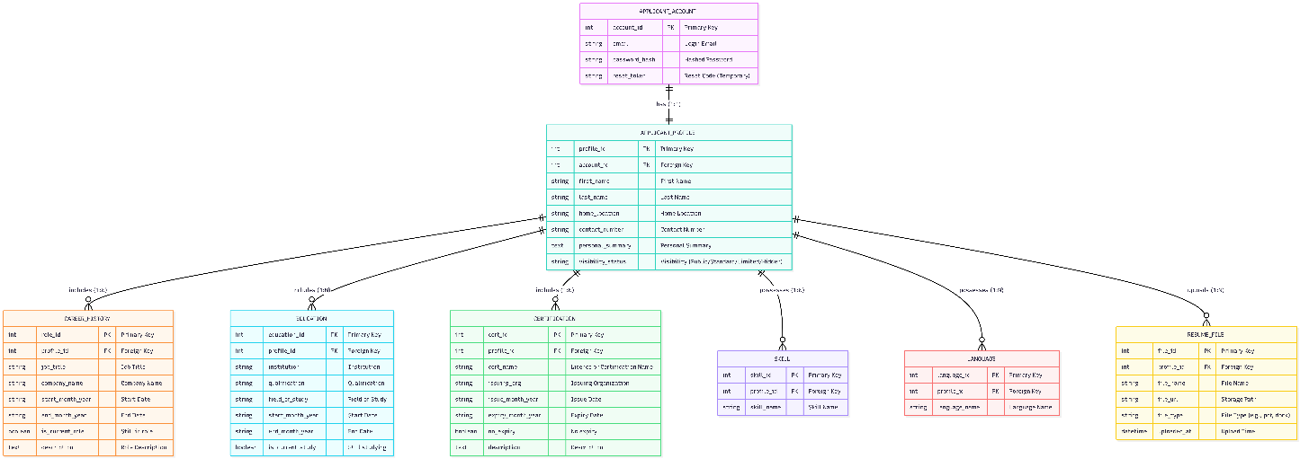
Figure 2: Physical 3NF database model highlighting APPLICANT_ACCOUNT and APPLICANT_PROFILE entities. Normalized 3NF database architecture, specifically highlighting the 1:1 relationship between APPLICANT_ACCOUNT and APPLICANT_PROFILE alongside 1:N sub-tables. 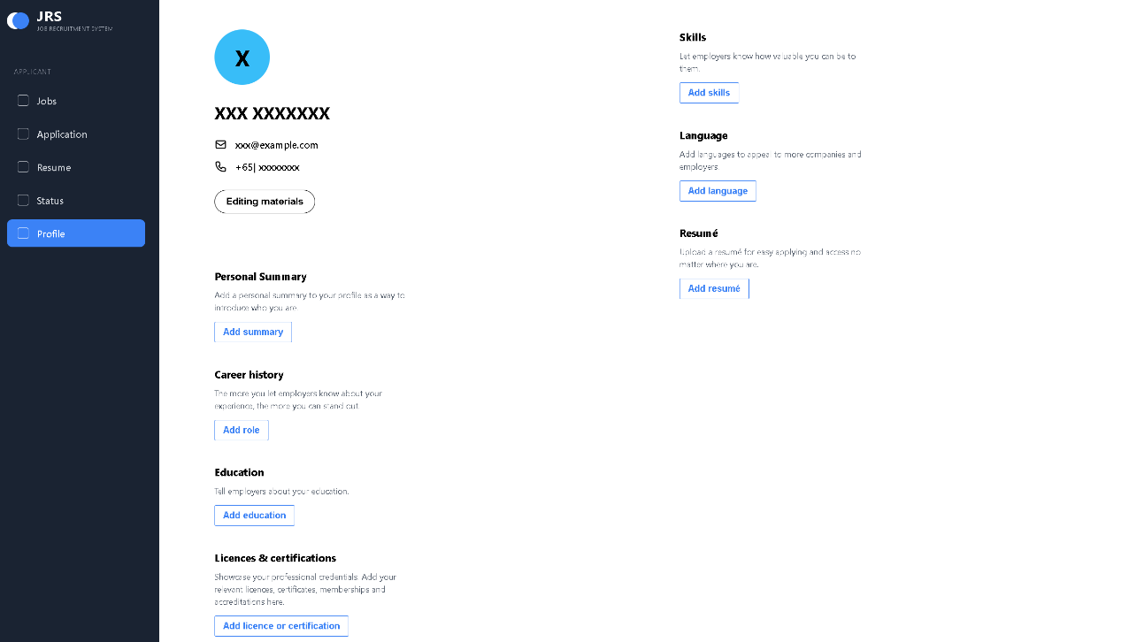
Figure 3: Translated HTML/CSS web page. Rendered HTML browser view matching the high-fidelity Figma layout specifications, confirming pixel-perfect alignment. 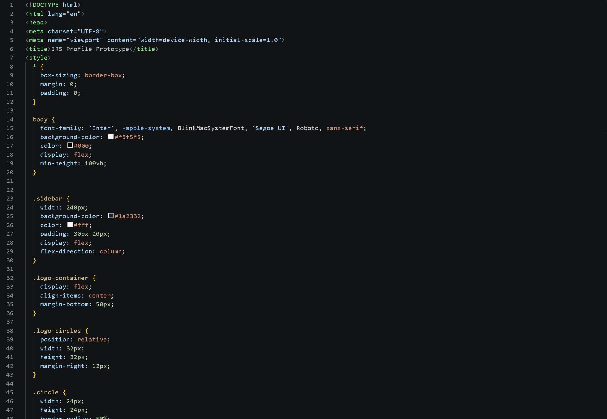
Figure 4: HTML5 structure and CSS Flexbox styling codebase. Captures the underlying HTML5 markup and CSS Flexbox layout logic written to construct responsive UI components.

3. Self-Directed Learning (Part A Achievements & Part B Roadmap)
Completing my assigned modules required independent learning beyond standard lecture materials.
Part A Self-Learning Accomplishments
- Figma Auto-Layout & Design Tokens: I taught myself Figma's advanced auto-layout system and component state variants to create scalable UI wireframes.
- Modern CSS Flexbox Layouts: I studied CSS Flexbox container properties, media queries, and responsive grid structures to ensure accurate web translation of visual prototypes.
- Relational Database Normalization: I reviewed 3NF normalization rules to verify that fields collected in registration forms mapped into normalized database entities without repeating groups or transitive dependencies.
Part B Planned Self-Learning
- RESTful API Data Binding: I will learn asynchronous JavaScript (async/await, Fetch API) to connect static HTML forms to live backend database endpoints.
- Dynamic State Management: I plan to study client-side state handling to update hiring statuses dynamically on the UI without requiring full web page refreshes.
- Input Sanitization & Security: I will study web application security practices to sanitize user inputs on registration forms, preventing Cross-Site Scripting (XSS) and SQL injection risks.
4. Project Management Tools and Governance
Project management tools played a critical role in facilitating structured progress, maintaining quality control, and ensuring the timely completion of all deliverables throughout the Phase 1 development lifecycle.
- Work Breakdown Structure (WBS) & Task Tracking: I systematically mapped my individual deliverables—specifically the HCI design specifications, FRS mapping, and front-end layout implementation—against our project's Work Breakdown Structure. By decomposing high-level milestones into manageable weekly task increments, I was able to monitor personal progress, identify critical path dependencies early, and allocate dedicated time buffers for peer testing and review. This structured approach effectively prevented task clustering before submission deadlines.
- GitHub Repository & Version Control Governance: We utilized a shared GitHub repository as the core version control infrastructure for our source code. I adhered to disciplined Git workflows by pushing HTML5 and CSS3 code modules through clean, well-documented commits. To minimize integration friction, I maintained modular file structures for my UI components, allowing database and backend team members to seamlessly access and reference static templates without code conflicts.
- Figma as an Interactive Visual Contract: Beyond prototyping, Figma acted as an asynchronous collaboration platform and the single source of truth for our entire team. By establishing standardized UI component libraries, responsive breakpoints, and design tokens, I provided our database designer and system architects with a clear visual specification. This eliminated ambiguity regarding required form inputs and data fields, directly streamlining the translation of UI requirements into backend 3NF database schema definitions.
- Asynchronous Coordination and Governance Artifacts: To complement scheduled meetings, we leveraged shared project governance documentation, including bi-weekly meeting logs and updated Gantt charts. I actively referenced these governance artifacts to align my personal sprint goals with the overall team timeline, ensuring my front-end modules were delivered ahead of scheduled integration milestones.
5. Meeting Frequency, Attendance, and Active Participation
Our team maintained a consistent communication schedule throughout the development cycle.
- Meeting Frequency: We conducted bi-weekly progress meetings with our industry supervisor to report progress, alongside bi-weekly internal team syncs supplemented by brief Wechat check-ins during integration phases.
- Attendance Record: I maintained a 100% attendance record across all scheduled supervisor sessions and team meetings.
- Participation Style: I actively participated in discussions. During meetings, I presented my Figma wireframes to validate user flows and walked team members through UI layout structures to ensure frontend-to-database compatibility.
6. Team Interactions, Timeliness, and Quality Delivery
Collaboration within the group was professional, constructive, and organized around shared milestones.
- Timeliness: I prioritized early delivery, completing my Figma UI specifications and HTML/CSS web skeletons 2 to 3 days ahead of internal team review dates.
- Work Quality: Submitting my deliverables ahead of schedule gave the team sufficient buffer time for review. Delivering the UI layout early allowed our database developer to verify table relationships before finalizing SQL schema scripts, preventing last-minute rush work and maintaining high technical standards across project outputs.

